PRESCOTT FINE ARTS & WINE FESTIVAL

By MOUNTAIN ARTISTS GUILD

Dear Vendors,

Thank you for your interest in the Mountain Artists Guild's 33rd annual Fine Arts & Wine festival in historic Prescott, Arizona! We look forward to seeing you again May 11-12, 2019.

There are some important changes you need to be aware of. If you were with us in prior years, you know that last year we lost 31 spaces. This year, an additional space was held out to rest the grass around the Courthouse Plaza. Because this show is always sold out, your early registration is vital if you want to have the best opportunity to be juried in for this show.

A map is enclosed of the new space numbering system. Spaces 33, 34, 35, 67 and 77 have been permanently removed. Spaces 4B and 116B have been added. The 9 spaces "resting the grass" and out of service this year are: 38, 39, 66,105, 106, 108, 109, 150 and 152. Most spaces are 15 ft, but there are some 10-foot spaces, such as 11, 12, and 21. Where space allows, booths can run 10' across and 15' deep as well as the standard 15' across and 10' deep.

On your application form, there is a place where you can request your favorite locations. We can't guarantee you will get one of them. If your favorite spot is one of the spaces not available this year, this is a chance to mix it up, and try another location.

Secondly, we have vendors who must have electric service in order to be an exhibitor. Spaces with electrical access are extremely limited. If you don't need electricity, please do not expect that we will give you a space with electricity if we need it for a vendor who must have it.

All work must be juried into the show. Applications must include a description of the items to be offered for sale and the method by which such items are produced, along with photographs. Items offered must be handmade or significantly embellished. Photographs must include 2 or more of the items to be sold, one of the artist's booth, and one of the artist creating their work. Photos will not be returned. Photos may be submitted by mail with the application, or by email to festivals@mountainartistsguild.org,

Food Service Booth exhibitors must contact the Yavapai County Health Department for proper licensing and instructions. 928-771-3149 or www.vavapaiheal th.com. There are a limited number of booth spaces along Gurley Street. There are no accommodations for trailers or food trucks. Only fireproof canopies may be used. "Cottage Edibles" (pre­ packaged food items) are a separate category and may be interspersed within the show,

with samples provided to public according to Yavapai County Health Department regulations.

LICENSES REQUIRED:
- You are required to have a Prescott Business License. This license is $35 annually and expires December 31st of each year. You can get this online at
www.prescott-az.gov/business/license/. If you have questions, call City of Prescott Tax & Licensing at 928-777-1268. This license is needed for all shows you plan to participate in on the Courthouse Plaza in 2019.
- You are required to have an Arizona Tax ID number. You may apply for this at www.aztaxes.gov. There is a one-time $5 fee. Each exhibitor is responsible for the collection of appropriate sales tax. The AZ Tax ID is required for all shows you participate in on the Courthouse Square.

Your completed application and licenses, along with full payment, are due upon acceptance into the festival. Applications that are not accepted will be refunded less the jury fee. Cancellations prior to March 31, 2019 will be refunded less a $30 handling fee. This is a rain or shine event, and no refunds will be given due to weather conditions.

There are specific requirements of vendors that we have been given by the city of Prescott:

- All tents must be placed flush with the curbing.
- There can be no rugs or ground covers on the grass.
- All items must be 2 inches off the ground. You can store items such as cardboard boxes, behind your tent in a space two feet deep and not wider than your 15ft or 10ft space. These items must be off the grass, placed on 2"x4"xl2" boards to minimize grass contact. Weights to secure tents must be suspended off the ground
- No tent stakes, nails, spikes, yard art, etc., may be driven in the ground. Violation of this rule will result in an automatic $50 fine per stake.
- Food vendors must have tarps in their booth space. Food vendors are allowed one
20-amp circuit with 2 outlets.
- No items may be propped against a tree, statue, or park furniture.

Only items that have been juried may be sold. Your booth is to remain open during all hours of event, with artist present. If you need a booth sitter for a necessary break, a volunteer will be provided to cover for you. No smoking is allowed within 10 feet of any booth. SHOW HOURS are Saturday 9-5, and Sunday 9-4.

Security is provided each night of the event. Security guards have suggested you leave a battery-operated light on inside your show tent at night so patrols can clearly detect anyone inside. Mountain Artists Guild is not liable for loss or damage. Exhibitors leave their work at their own risk.

No vendor can put any trash in or beside the small trash cans around the Courthouse Plaza. You must place ALL your trash in the large dumpsters provided on the south side of the Courthouse or take your trash with you.

INTAKE PARKING: Friday evening - Spaces around the plaza are reserved for vendors. Please display your loading pass on your dashboard when unloading/loading at the Plaza. Loading passes will be available at check-in.

INTAKE process will begin at 5:00, but booth setup is not allowed until the last judge leaves the plaza, which could be as late as 6 pm. Check-in continues Saturday morning at 6:30am. All setups must be completed by 8:30 am Saturday.

SETUP: No driving or parking is allowed on bricked areas and sidewalks. You must stay on the concrete if you drive onto the plaza to unload close to your booth. If damage occurs, Yavapai County will charge the exhibitor for repair and clean-up costs. As soon as you have unloaded, remove your vehicle from the square area.

STORAGE:

PARKING: Vendors are not allowed to park within two blocks of the Courthouse Plaza during the show hours. Parking can be provided at Granite Street Parking for vehicles only. Please indicate this on your application.

END OF SHOW: All vendors MUST be gone from the Courthouse Plaza by 5:30 pm on Sunday. The space you have just vacated can have no debris remaining, including things as small as little white price tags that have fallen off artwork, or empty water bottles. If we are fined for items found on your space, you will be charged for the fine.

City Parking Lot-40 spaces just north of The Porch
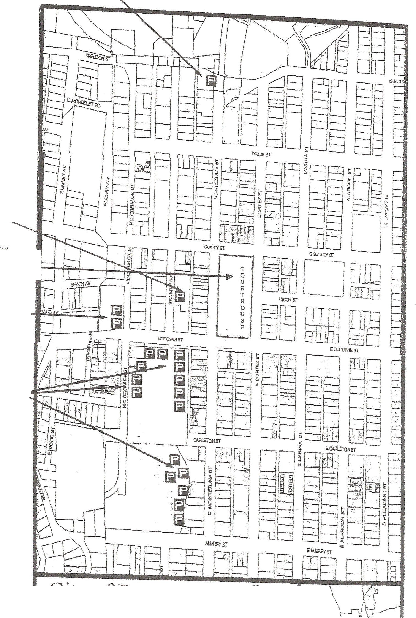

City's Granite Street
Parking Lot

Yavapai County
Courthouse Plaza c

Goodwin Street Plaza
Spaces fronting 0
u
McCormick only please.

Mile High Middle School Field
Teachers lot only

City of Prescott
Fine Arts & Wine Vendor Parking Locations

